Study Status
Data was pulled on 2026-03-10.
Figure 1. Enrollment Status
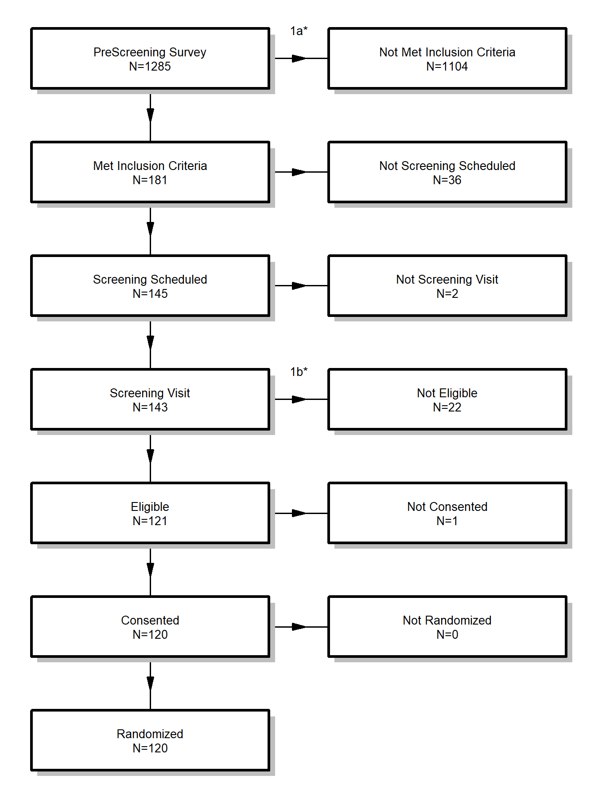
Final enrolled number is 120.
*These exclusions are covered in the indicated table.
Table 1a. PreScreening Inclusion Criteria
Inclusion Criteria | Number Failed
Survey 1 > 10 | 706
Survey 2 > 8 | 674
Hypertension/Hypotension | 333
Ability to do study | 151
Some subjects failed to meet multiple inclusion criteria.
Of the 1285 subjects who completed the prescreening survey, 1104 did not meet at least 1 inclusion criteria and 181 met all inclusion criteria and were able to be scheduled for a screening visit.
Table 1b. Exclusions at Screening Visit
Exclusion | Number Excluded
Hypotension in Screening Visit | 1
Hypertension in Screening Visit | 21
Of the 143 subjects who completed the screening visit, 22 were excluded based on one of these criteria and 121 were eligible for randomization.
Table 2. Demographics (Enrolled Only)
N=120 | Type/Level | Summary | # Missing
Sex | Female | 56 (47%) | 0
 | Male | 60 (50%)
 | Other | 1 (<1%)
 | Prefer not to answer | 3 (2%)
Age | [mean (SD)] | 44.7 (8.2) | 0
 | [median (IQR)] | 44 (38.8, 49.2)
 | [range] | (26.0, 68.0)
Race | White/Caucasian | 103 (86%) | 0
 | Asian | 8 (7%)
 | Two or More Races | 3 (2%)
 | Native Hawaiian/Pacific Islander | 2 (2%)
 | Black/African American | 2 (2%)
 | Native American/Alaska Native | 2 (2%)
 | Other | 0 (0%)
 | Prefer not to answer | 0 (0%)
Ethnicity | Not Hispanic or Latino | 95 (79%) | 0
 | Hispanic or Latino | 25 (21%)
Race/Ethnicity | White/Caucasian, Non-Hispanic/Latino | 82 (68%) | 0
 | Hispanic or Latino | 25 (21%)
 | Asian, Non-Hispanic/Latino | 6 (5%)
 | Two or More Races, Non-Hispanic/Latino | 3 (2%)
 | Native Hawaiian/Pacific Islander, Non-Hispanic/Latino | 1 (<1%)
 | Black/African American, Non-Hispanic/Latino | 2 (2%)
 | Native American/Alaska Native, Non-Hispanic/Latino | 1 (<1%)
 | Other | 0 (0%)
 | Prefer Not to Answer | 0 (0%)

Table 3. Physical Measures (Enrolled Only)
Variable | Baseline: N=120 | Week 8: N=105 | Month 6: N=78 | #Missing
SBP
[mean (SD)] | 112.1 (8.7) | 110.9 (10.6) | 105.4 (13.6) | 0 / 0 / 0
[median (IQR)] | 112 (106.8, 118) | 111 (103, 119) | 106.5 (93.2, 114.8)
[range] | (87.0, 129.0) | (87.0, 137.0) | (69.0, 132.0)
DBP
[mean (SD)] | 69.7 (6.2) | 68.2 (6.5) | 64.9 (7.5) | 0 / 0 / 0
[median (IQR)] | 71 (66, 74) | 69 (64, 72) | 64 (60.2, 70)
[range] | (49.0, 79.0) | (46.0, 83.0) | (41.0, 84.0)
BMI
[mean (SD)] | 31.0 (5.3) | 31.4 (5.3) | 31.1 (5.6) | 0 / 0 / 0
[median (IQR)] | 30.8 (28, 34.6) | 30.9 (28.2, 35) | 31 (28, 35)
[range] | (17.2, 43.5) | (17.4, 44.4) | (17.0, 44.0)

Table 4. Survey Scores (Enrolled Only)
Variable | Baseline: N=120 | Week 4: N=109 | Week 8: N=105 | Month 3: N=83 | Month 6: N=78 | #Missing
Score 1
[mean (SD)] | 20.3 (7.1) | 20.3 (8.0) | 20.6 (7.4) | 23.3 (11.5) | 22.6 (10.4) | 0 / 0 / 0 / 0 / 0
[median (IQR)] | 20 (15, 25) | 20 (15, 27) | 20 (16, 25) | 23 (16.5, 30) | 23 (15.2, 29)
[range] | (5.0, 37.0) | (1.0, 42.0) | (4.0, 39.0) | (0, 59.0) | (0, 50.0)
Score 2
[mean (SD)] | 6.9 (3.0) | 6.9 (3.1) | 7.3 (3.2) | 7.8 (3.9) | 7.6 (3.7) | 0 / 0 / 0 / 0 / 0
[median (IQR)] | 7 (5, 9) | 6 (5, 9) | 7 (5, 9) | 7 (5, 11) | 7 (5, 10)
[range] | (1.0, 14.0) | (1.0, 14.0) | (1.0, 14.0) | (1.0, 14.0) | (1.0, 14.0)
Self-Report 1
[mean (SD)] | 51.4 (14.8) | 48.2 (16.3) | 46.3 (15.6) | 44.5 (18.6) | 42.0 (18.4) | 0 / 0 / 0 / 0 / 0
[median (IQR)] | 52 (41.5, 62) | 50 (37, 59) | 48 (37, 56) | 46 (34, 57) | 43 (29, 54.8)
[range] | (17.0, 85.0) | (8.0, 90.0) | (10.0, 85.0) | (0, 80.0) | (0, 87.0)
Self-Report 2
[mean (SD)] | 51.6 (16.2) | 56.2 (16.7) | 62.2 (16.0) | 66.7 (17.5) | 75.8 (16.3) | 0 / 0 / 0 / 0 / 0
[median (IQR)] | 50.5 (39, 63) | 56 (45, 68) | 60 (50, 73) | 66 (55.5, 78) | 76.5 (64, 89.5)
[range] | (14.0, 88.0) | (19.0, 95.0) | (24.0, 100.0) | (20.0, 100.0) | (40.0, 100.0)

Figure 2. Study Progress
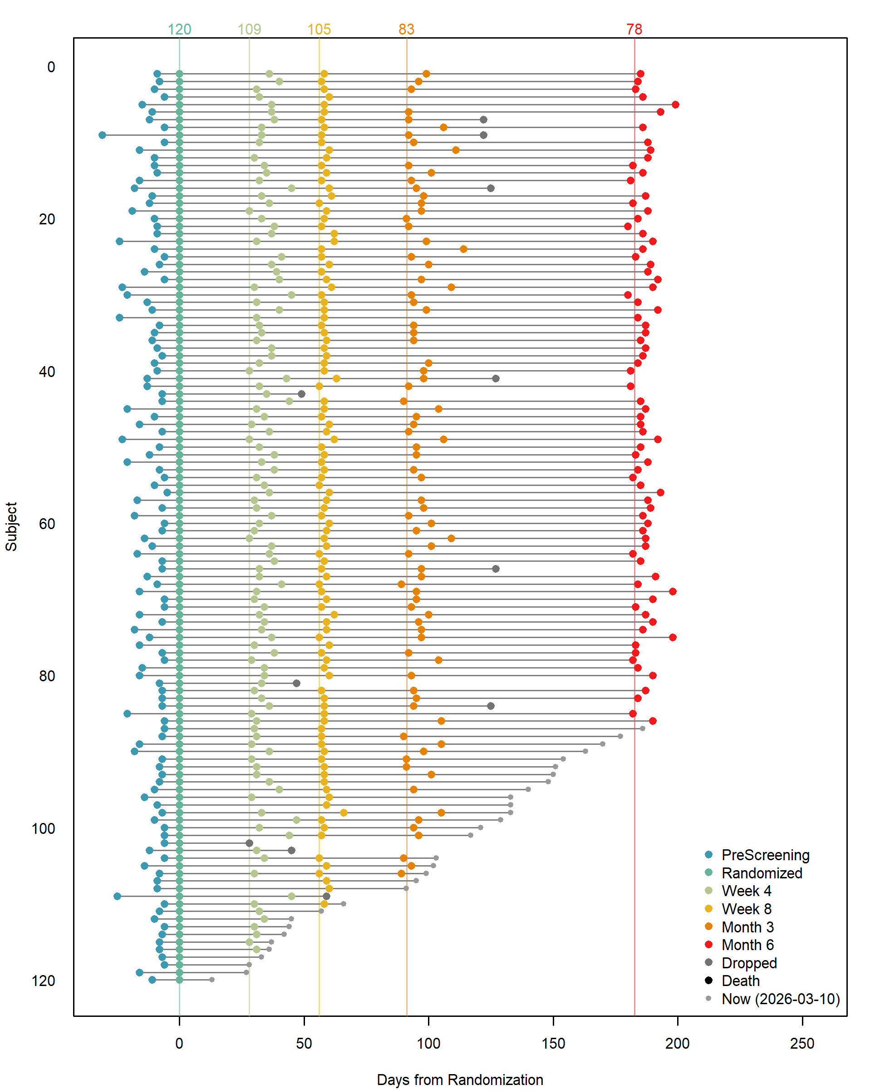
Days are from randomization time (negative are before).
Figure 3. Summary Study Progress (In-person Visits only)
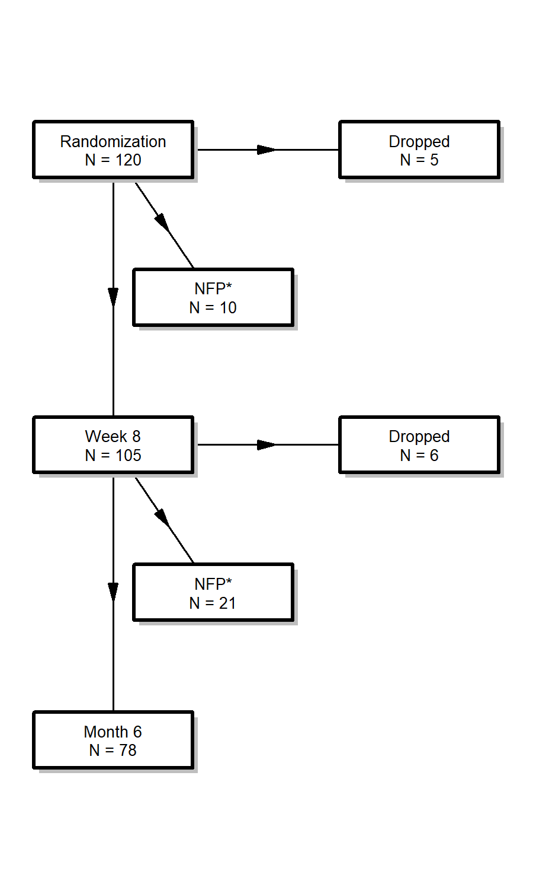
*NFP = No Further Progress: participants that haven't done the next visit, but have not dropped.
Drop out rate percentages below are calculated without considering the â€œNFPâ€ group. It is the percentage of those who dropped out of those who either dropped out or continued.
Drop Rate by Study Status:
- After Randomization and before the next visit there was a 5% drop out rate.
- 5 dropped out of 110 participants who either dropped or continued.
- After Week 8 and before the next visit there was a 7% drop out rate.
- 6 dropped out of 84 participants who either dropped or continued.
Based on the observed attrition rates, we would project that 106 of the subjects enrolled will complete the study (this includes the 78 who have already completed).
To reach the goal of 150 completed subjects, we estimate we need to enroll 50 more subjects, making 170 enrolled in total.
Figure 4. Subject Screening Numbers
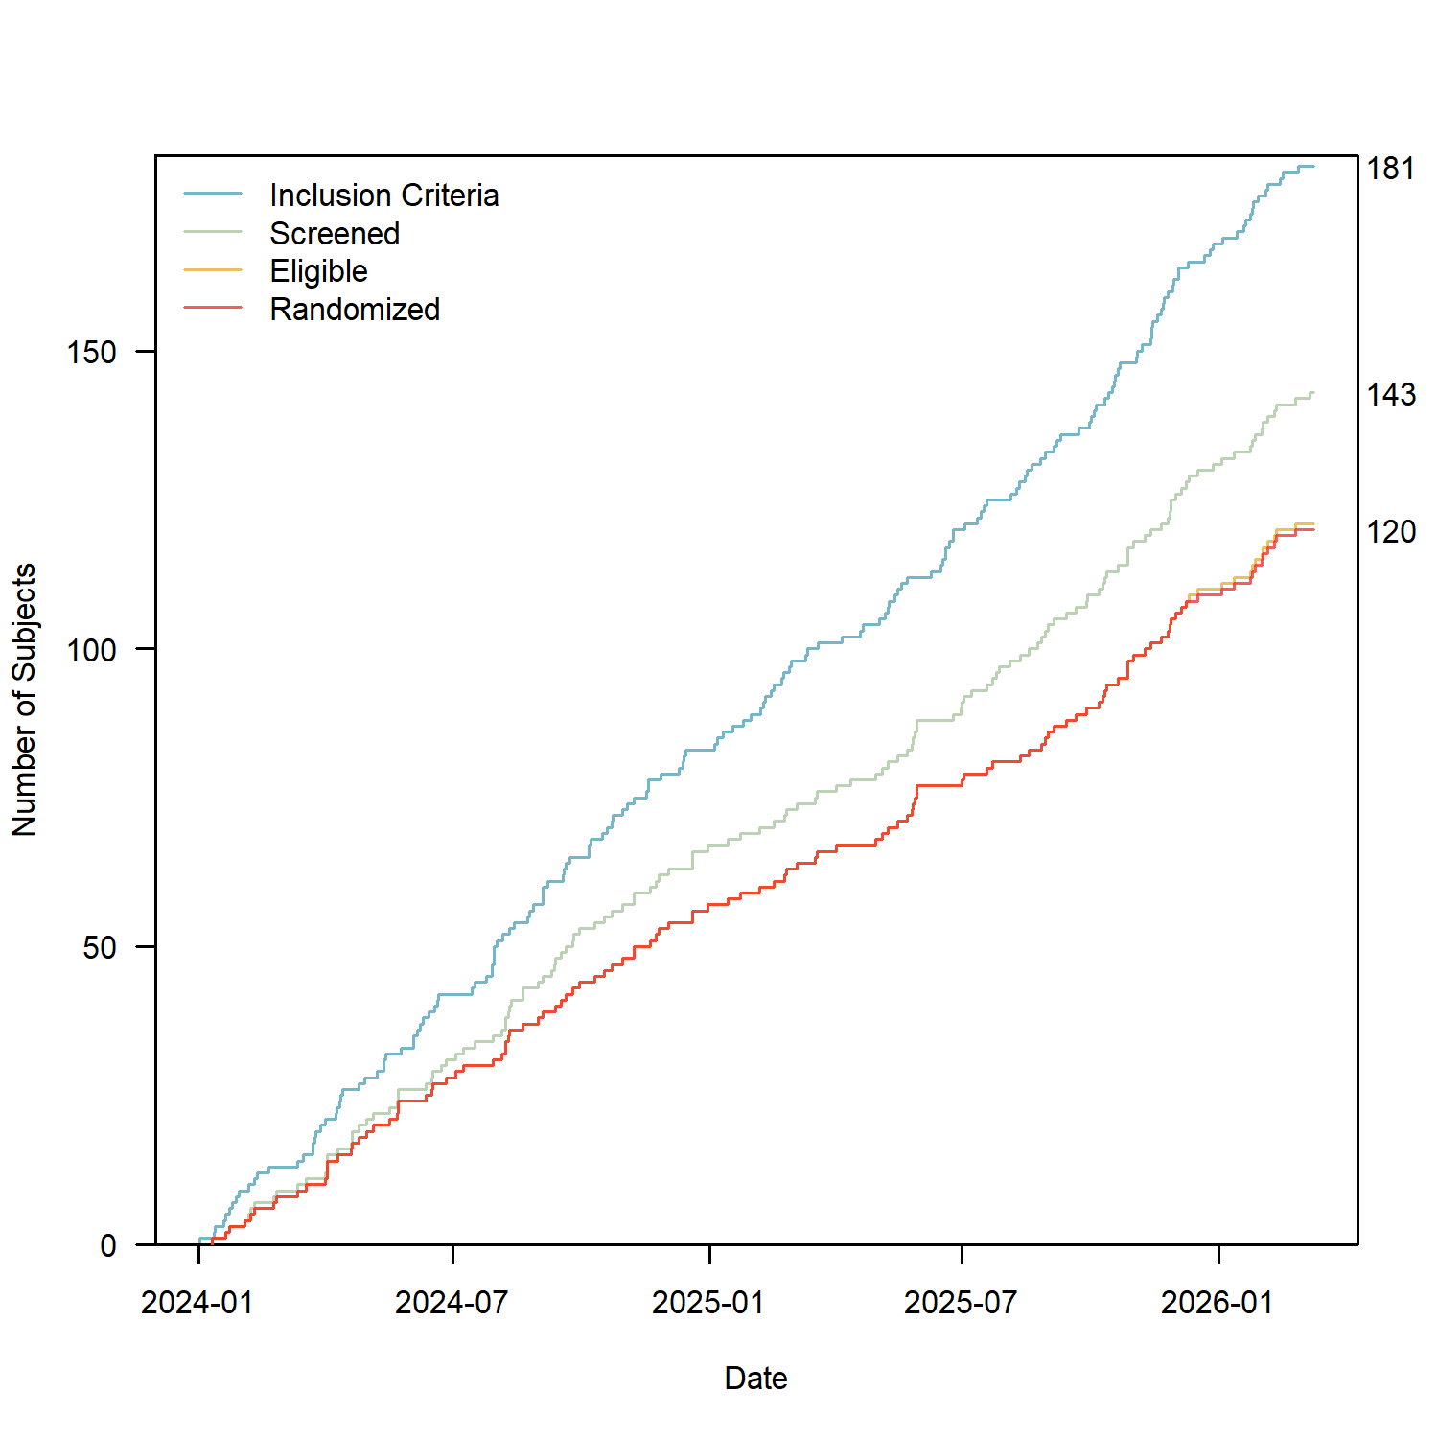

Figure 5. Enrollment Numbers
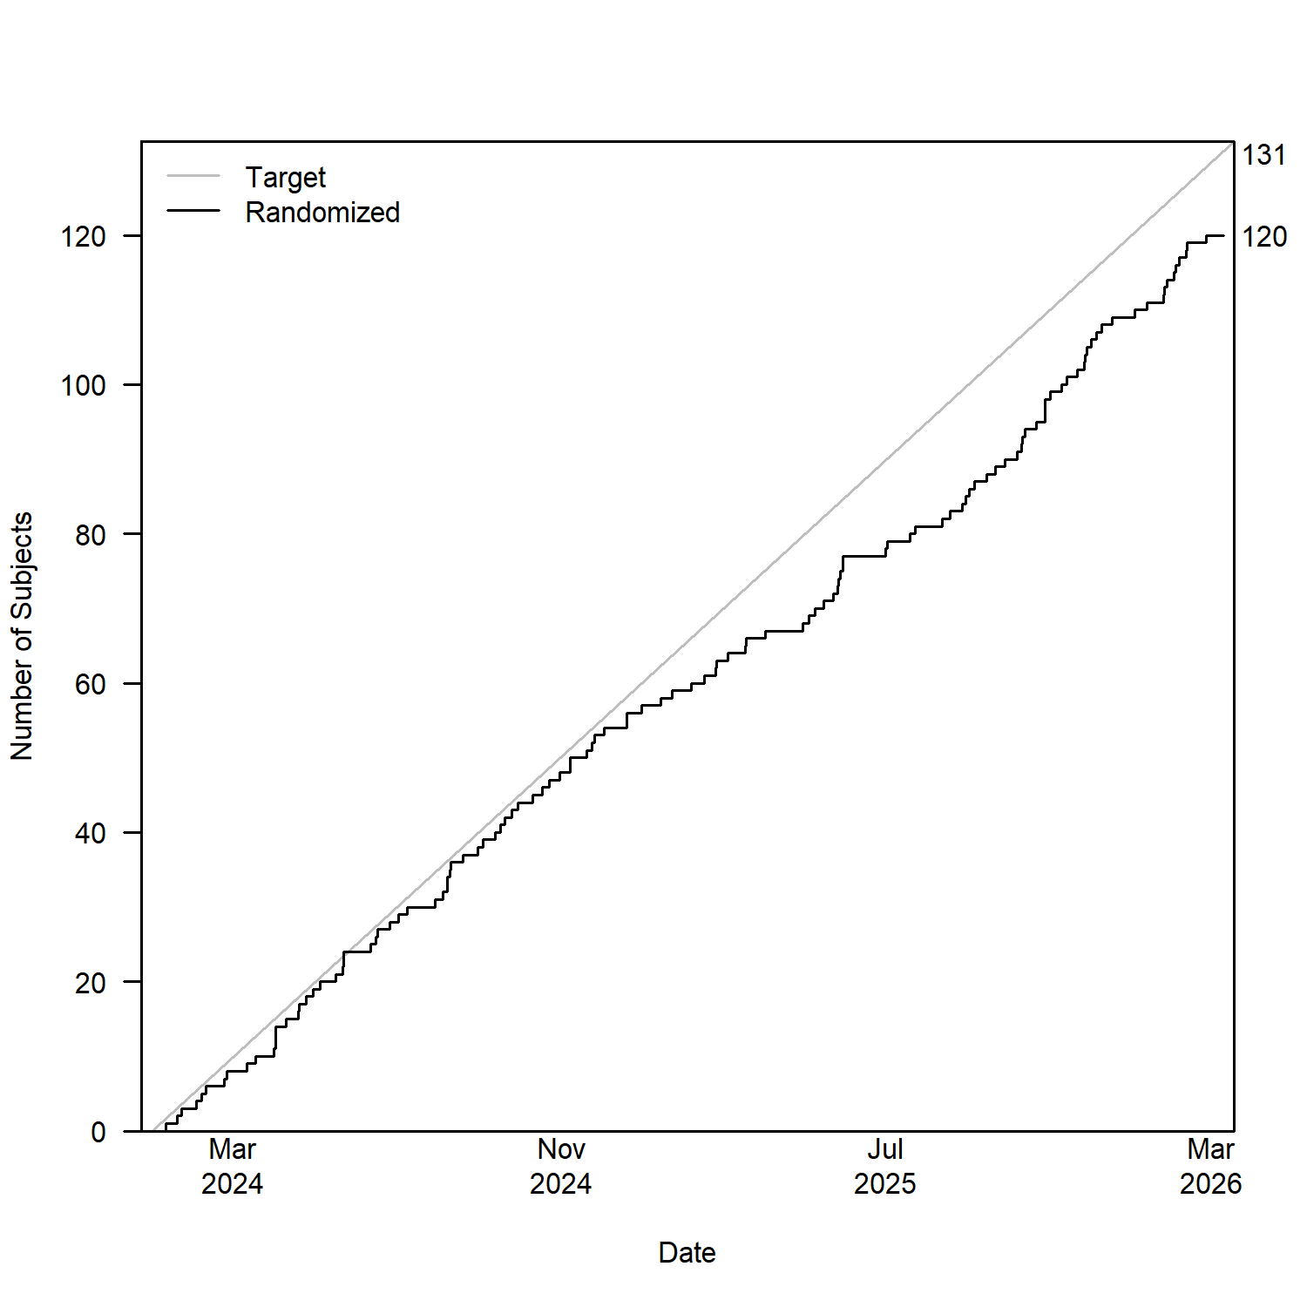
First day is taken as 2024-01-01. Our target is to enroll 5 per month.
Our overall enrollment rate is 4.6 subjects per month and the rate for the last 3 months is 4.3 subjects per month.
Figure 6. Projected Enrollment
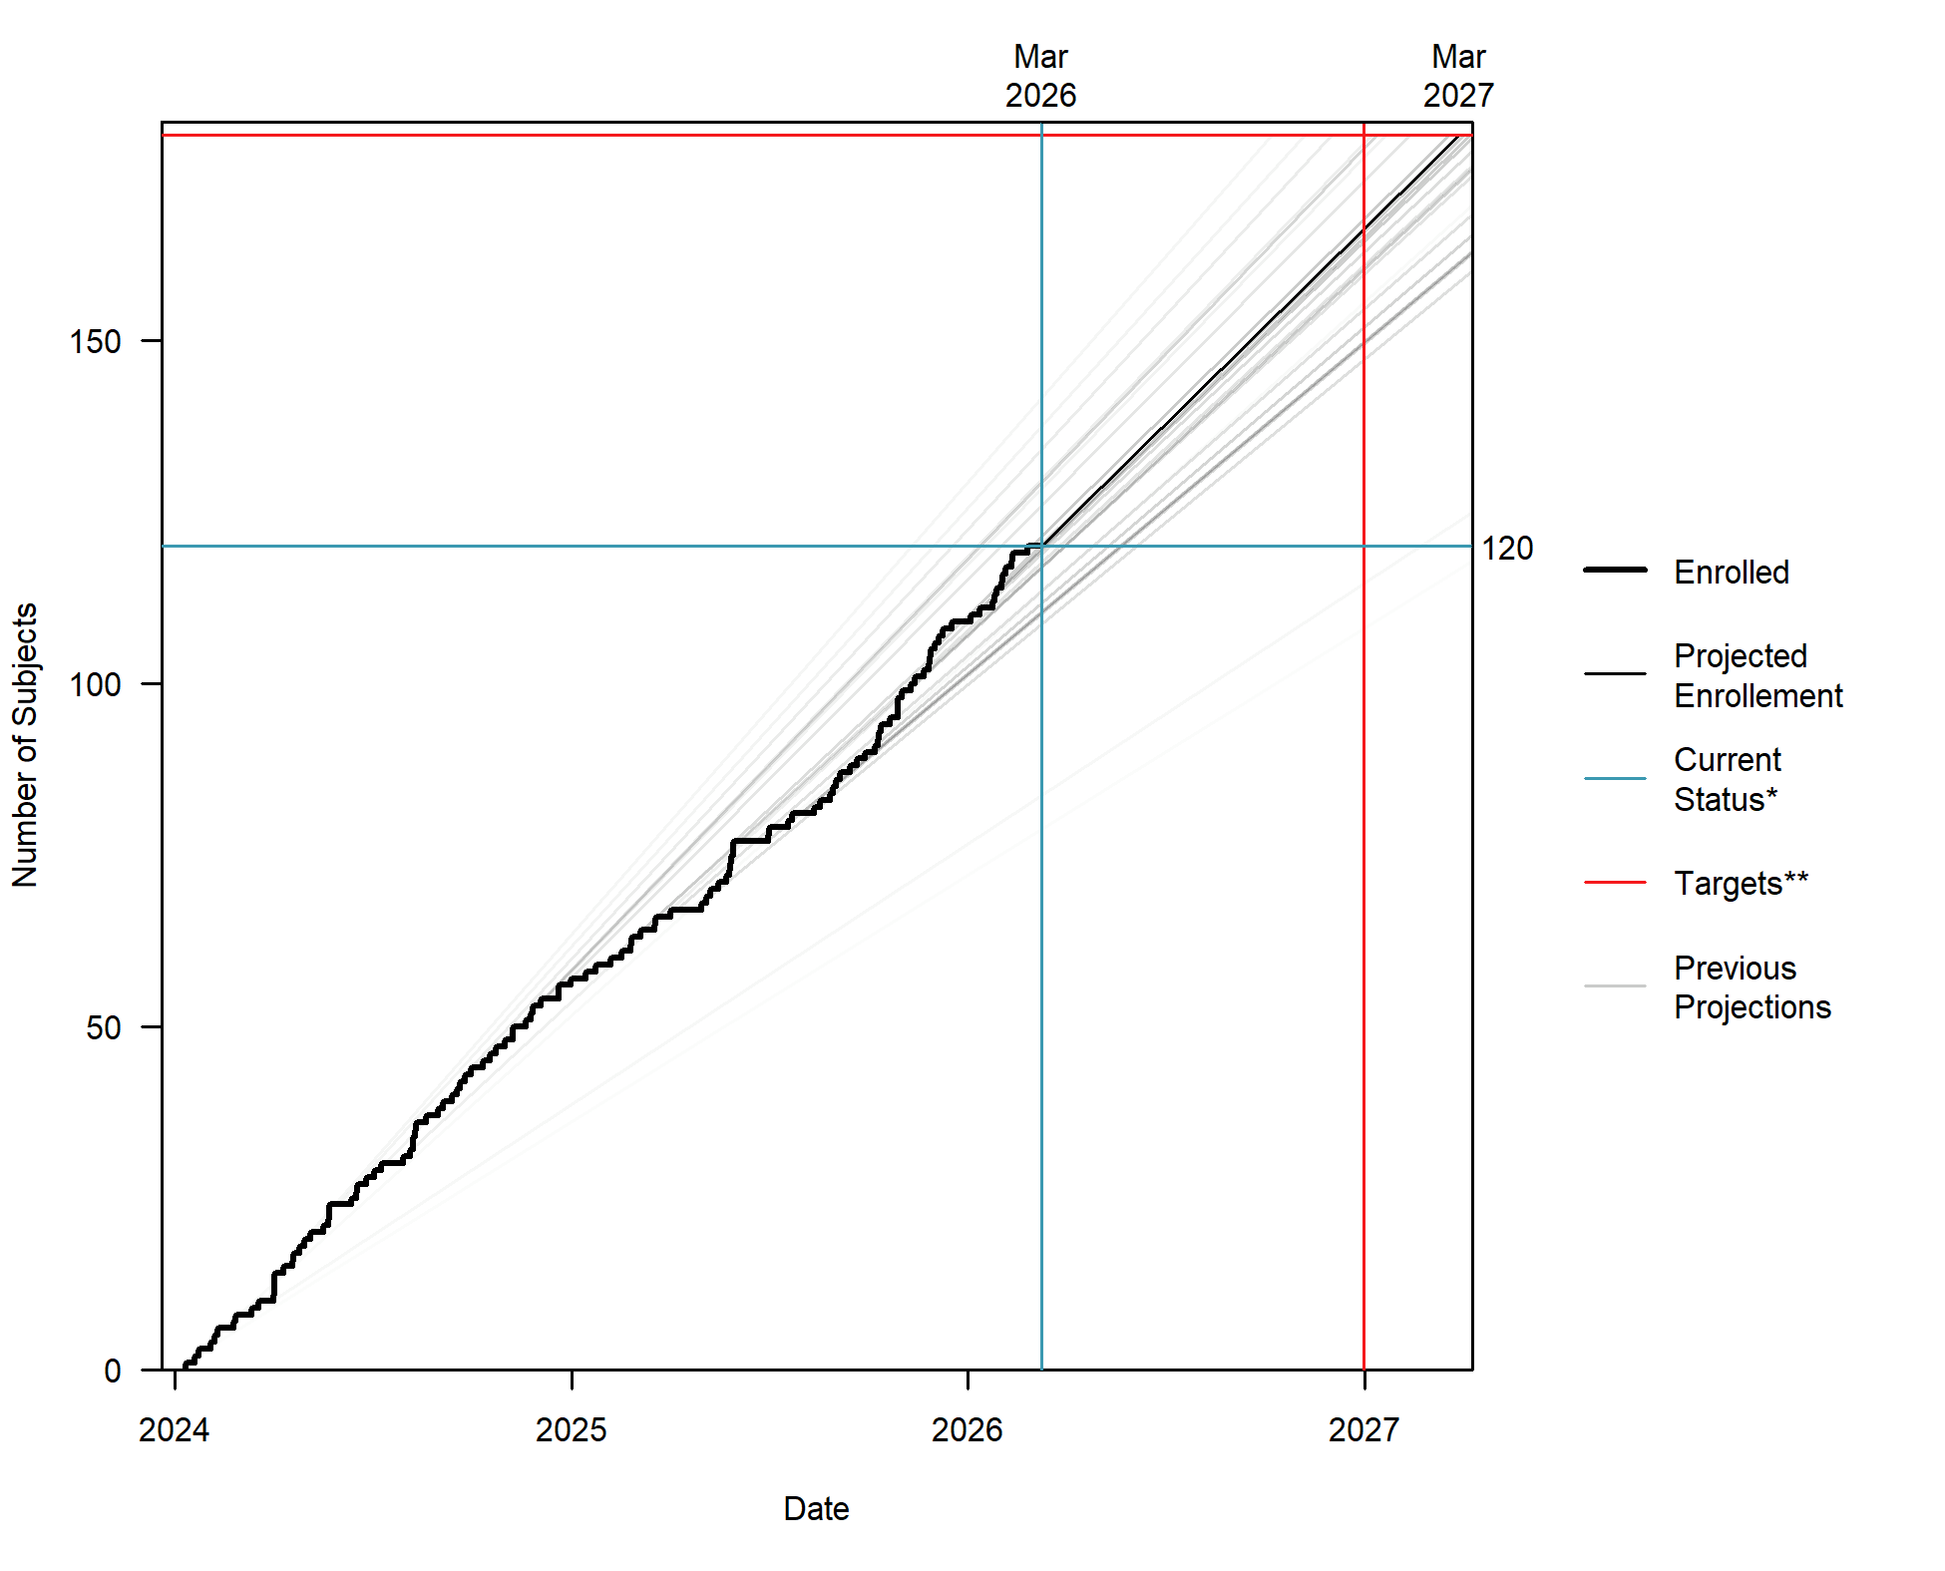
*Current Status is the current number enrolled, 120, and the date data was pulled, 2026-03-10.
**Targets is the targeted enrollment, 180, and the targeted end date, 2026-12-31.
At the current estimated pace of 4.74 enrollments per month we are projected to reach 180 by 2027-03-29, or projected to reach 166 by the end date, 2026-12-31. This estimated pace was produced with a weighted average of previous monthly enrollments and is recalculated on the 1st of each month.
In order to reach the targeted 180 subjects (60 remaining) by 2026-12-31 we need to enroll 6.17 subjects per month.
Enrollment for the past 3 months
Dec 2025: 4
Jan 2026: 5
Feb 2026: 6
Figure 7. State of the Study
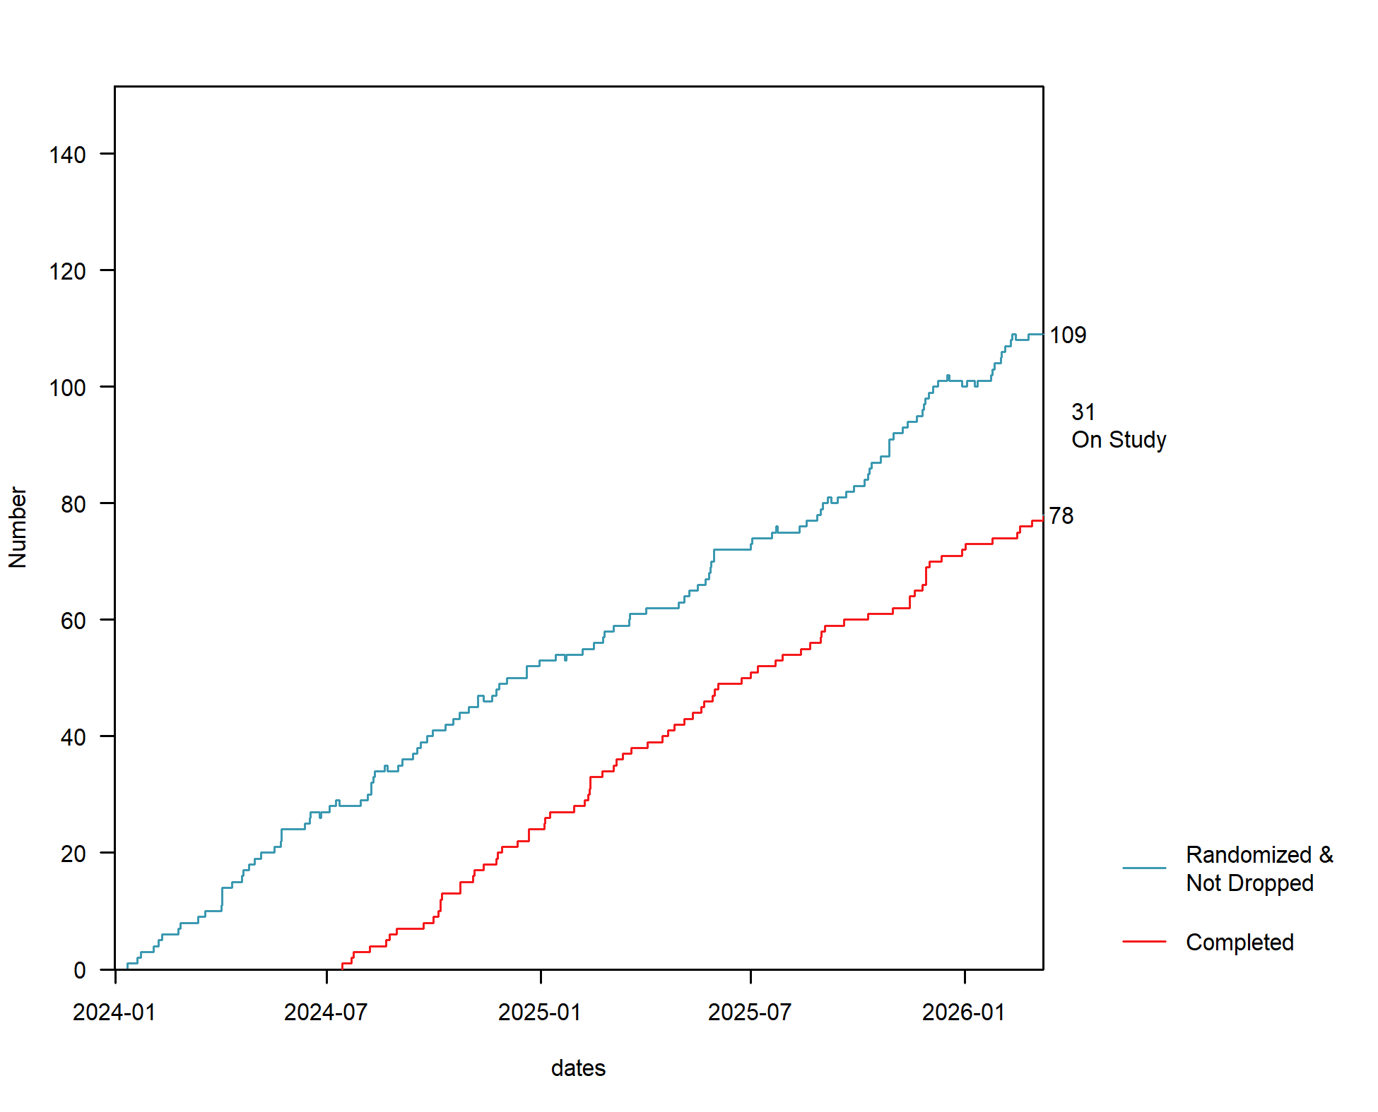
There are 109 subjects randomized that have not dropped. This figure includes the 78 subjects that have completed the study and the 31 subjects that are currently still in the study (i.e. have neither dropped nor completed).
Based on the observed attrition rates, we would project that 28 of the 31 subjects that are on study will complete it, making a total of 106 completed subjects.

